Design

1. Use case diagram

A use case diagram is a graphic depiction of the interactions among the elements of a system. A [use case](https://searchsoftwarequality.techtarget.com/definition/use-case) is a methodology used in system analysis to identify, clarify, and organize system requirements. In this context, the term "system" refers to something being developed or operated, such as a mail-order product sales and service [Web site](https://whatis.techtarget.com/definition/Web-site). Use case diagrams are employed in [UML](https://searchsoftwarequality.techtarget.com/definition/Unified-Modeling-Language) (Unified Modeling Language), a standard notation for the modeling of real-world objects and systems.

Use case diagram-figure

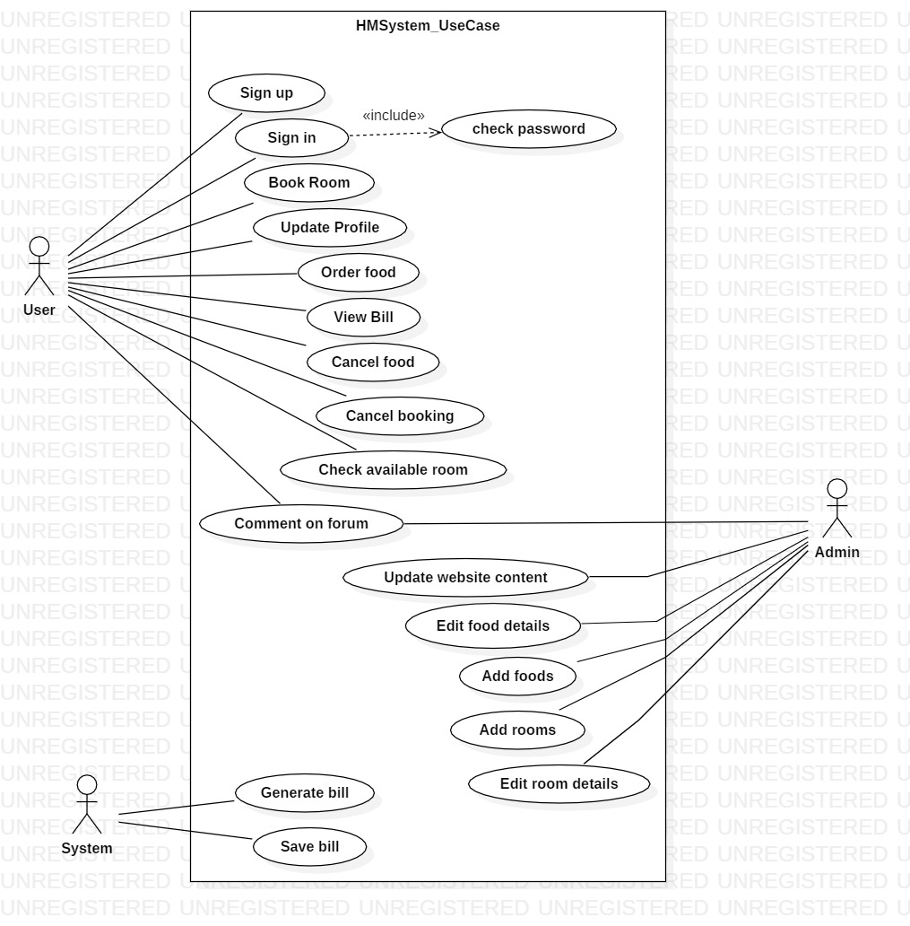

Explanation

For this project I have three types of different actor’s users, admin and system. The user is an actor who creates his/her account and uses the service provided through the application in short user is our customer. Which has privilege to sign up, book room, edit his/her profile, and orders different services. The admin is another actor, which has maximum amount of privilege to access the core part of the application. Admin can delete, manipulate, and update the each and every part of the application. Finally, system is actor which can be referred to as application, it calculates the overall bill and provides bill to the user.

Class diagram

A Class Diagram is a diagram that provides a structural view of a system by listing its object classes with relations between classes. Class diagrams describe systems by illustrating attributes, operations and relationships between classes. Unified Modeling Language (UML) calls them structure diagrams. They work according to the principles of object orientation. This orientation describes how objects interact with each other.

Class diagram figure

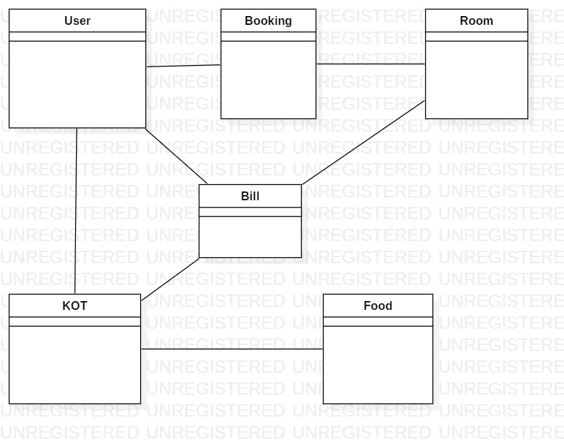

Explanation

Here I have prepared a initial class diagram, this class diagram prepared with-out any attributes or function. As, the project’s get’s completed I will be addressing all the required attributes and function to it.

ER-diagram

An entity-relationship diagram (ERD) is a data modeling technique that graphically illustrates an information system’s entities and the relationships between those entities. An ERD is a conceptual and representational model of data used to represent the entity framework infrastructure.

The elements of an ERD are:

* Entities
* Relationships
* Attributes

ER-Diagram- Figure

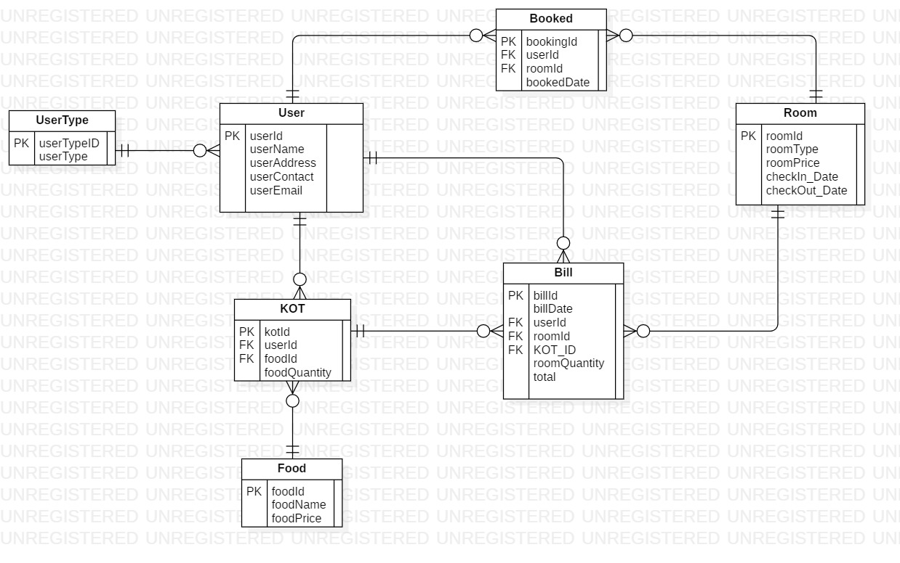

Explanation

In this diagram all the possible attributes of entities are well connected through relationship. As in the above figure the user has interrelation between KOT, Booking and Bill this relation shows that the userId is associated to provide information to other entities as for e.g.: we can know which user has booked the room and ordered food. In this way other entities are also connected with each other.

UI-design

Index page

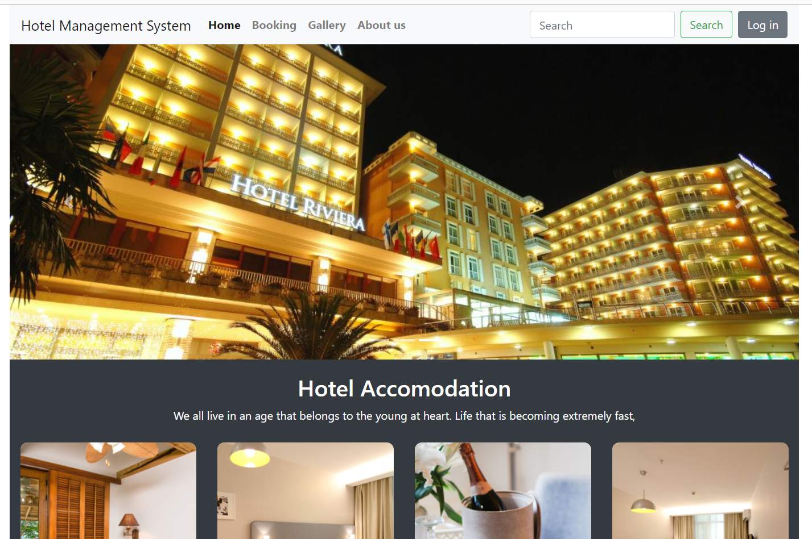

Booking page

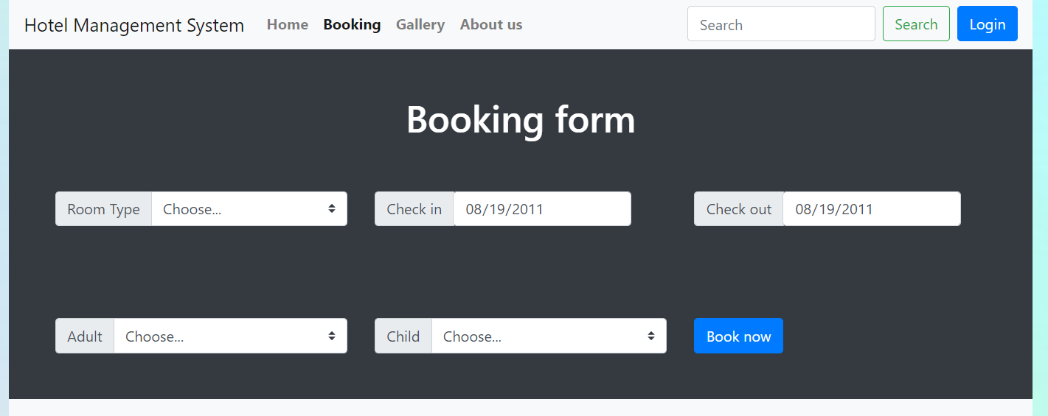

Gallery page

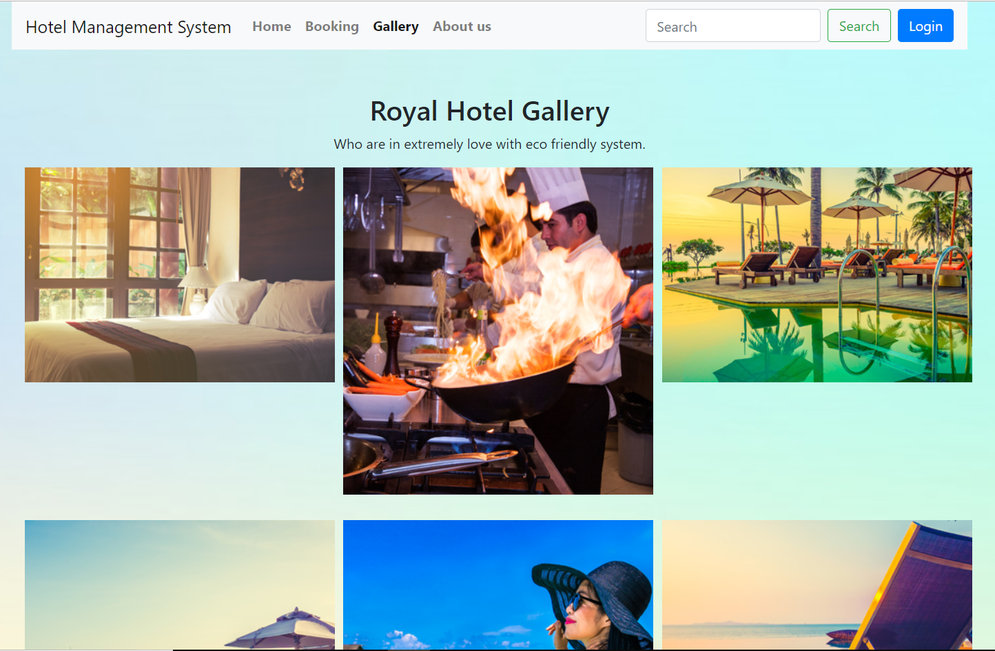

Activity diagram

Activity diagram is another important behavioral diagram in UML diagram to describe dynamic aspects of the system. Activity diagram is essentially an advanced version of flow chart that modeling the flow from one activity to another activity.

Activity diagram- Figure

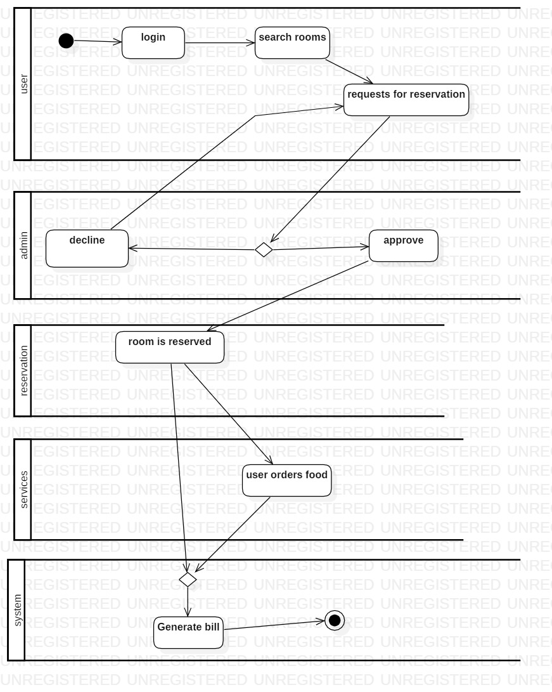

Explanation

As seen on above diagram firstly the user login into to system and search rooms, for the reservation the request will sent to the admin accepts or declines the request. If the admin accepts the request then the user successfully books the room. While in the room user can order any services. Finally when the user request for the bill, then the system will provide the bill according to their services *(used by the user)*.

Sequence Diagram:

Definition

The sequence diagram is used primarily to show the interactions between objects in the sequential order that those interactions occur. Much like the class diagram, developers typically think sequence diagrams were meant exclusively for them. However, an organization's business staff can find sequence diagrams useful to communicate how the business currently works by showing how various business objects interact.

Figure: Sign in sequence diagram.

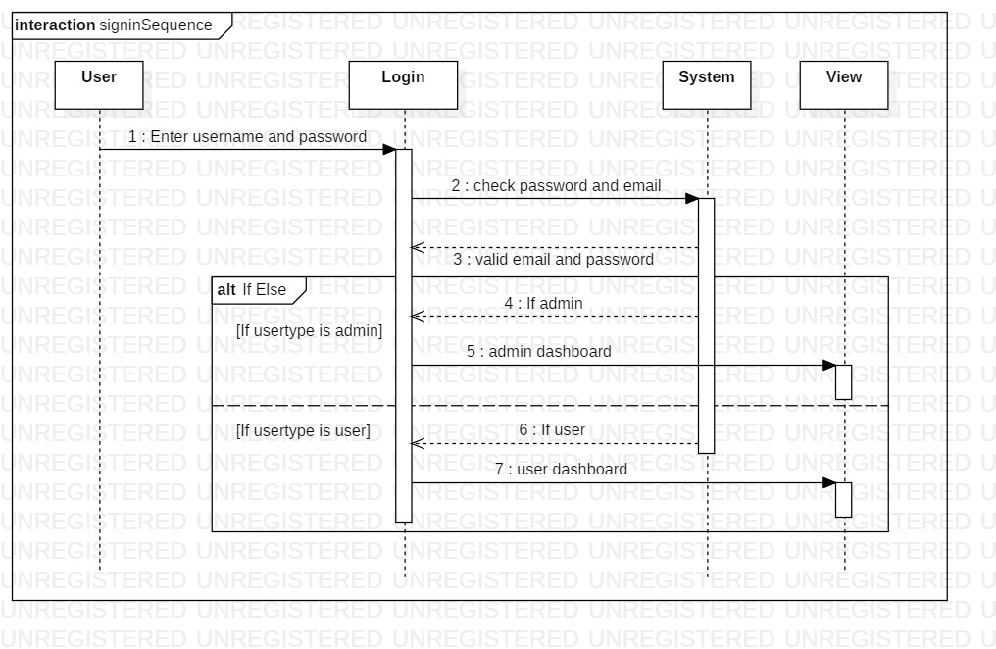

In hotel management system the user firstly enters the email and password. The data is then checked by the system weather the credentials are correct and valid. If the given credentials are true then according to the user type “Admin” or “User” the system directs to their dashboard respectively.

Figure: Room booking sequence diagram.

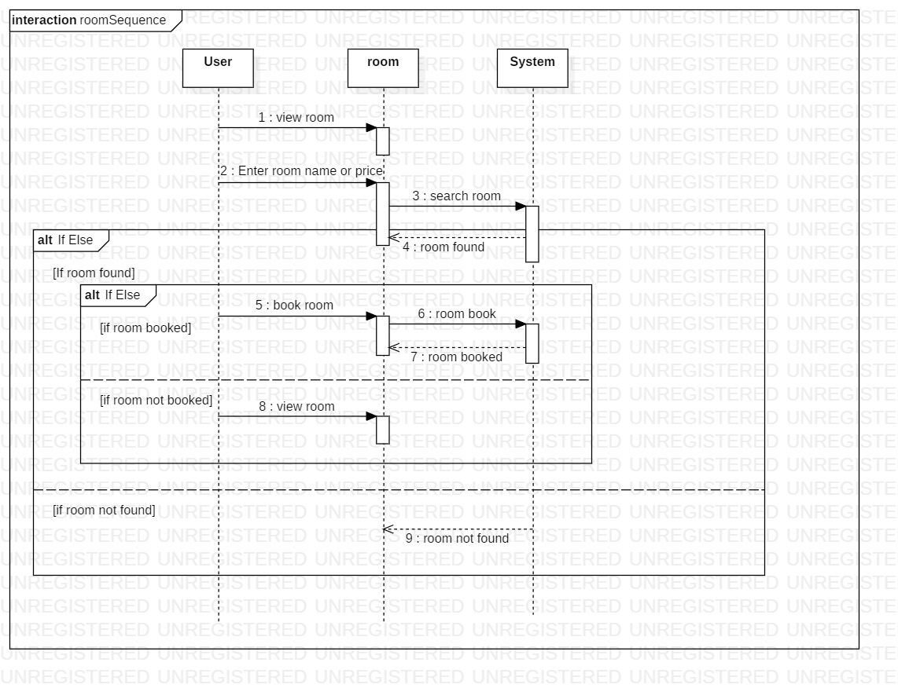

After the login user can see multiple rooms for booking. And if user want to search the rooms they can search according to name and price. If the desired room is found then the user finally books the room and if the room is not found then again user is prompted to view page of rooms.